**LB-LINK WR450D Router TFTP Tools upgrade tutoria**

Note: Upgrade using a cable connection, do not use a wireless connection!

1. **Cable connection: Disconnect all the cables from the router, and connect only the upgrading computer to router’s LAN port** (TFTP Tools only supports cable connection upgrade, please do not use a wireless connection.)

2. **Configure the local network card IP address as: 192.168.16.123** (TFTP Tools only support this IP address, other IP addresses are not recognized) :

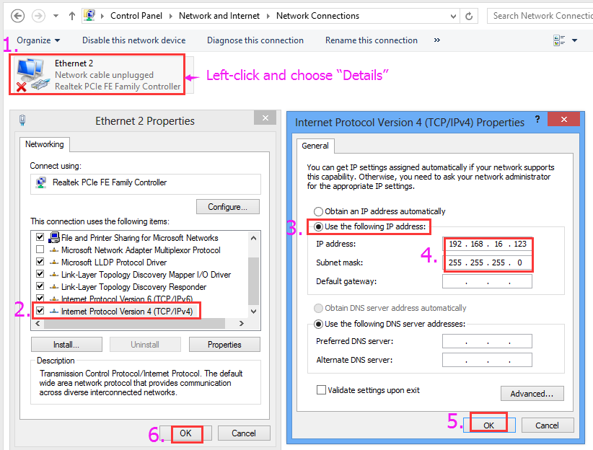

**3. Put the upgrade file and TFTP Tools in the same folder, and change the file name to "uImage"** (The file name may be "root_uImage" or "eCos.img"; first use the default file name "uImage" if this does not work, then check the TFTP Tools log to learn the specific upgrade file name.)

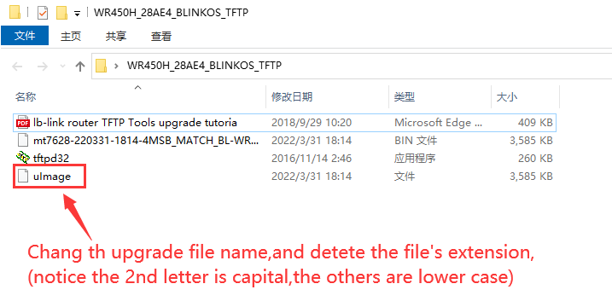

**4: open the TFTP upgrade tool.**

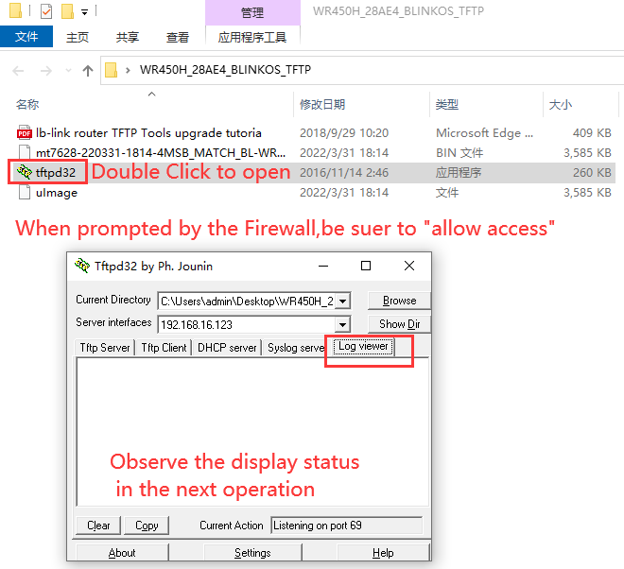

**5. Unplug the router for more than 10 seconds**.**Then holding down the reset reset button, plug it back in, then let go of the Reset button after 7 seconds.** **At the same time watch the TFTP upgrade tool for a change:**

(Note: Start from here, after 2 minutes, do not disconnect power cord from the router, or router will not work any more. )

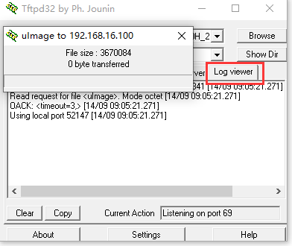

**Wait for 1 to 2 minutes, change the local network adapter (card) to "Automatically Obtain", see whether it can successfully get the IP, and gateway, and access the webpage. See whether the firmware version is changed (if not, you need to manually reset again, then check the firmware version again.)**

**6. Verify whether the upgrade is successful** (Ping the gateway first, then go to 192.168.16.1)

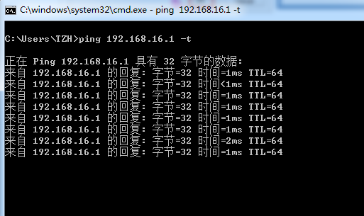

**Note: TFTP Troubleshooting:**

Look at the TFTP Tools "Log Viewer" information:

1)、If the "Log viewer" window is blank without any information, there are 2 reasons:

A. TFTP Upgrade Error, the router failed to boot from the TFTP uploaded firmware upgrade.

B. The router does not support the TFTP upgrade method (Uboot routers before September 2015 do not support TFTP Tools upgrades.)

